DATA ANALYTICS BY TABLEAU

# **VOYAGE VISTA :** **UNLOCKING INSIGHTS INTO THE GLOBAL AIR TRANSPORTATION NETWORK.**

S.Sarumathi, M.Hemamalini, P.Sushmitha, S.Swathi.

# DEPARTMENT OF MATHEMATICS

# Krishnasamy College of Science , Arts and Management for Women.

# Cuddalore

# C:\Users\SAKTHI\Downloads\download.jfif

# CONTENTS:

# 1.1 INTRODUCTION

# 1.1 Overview

# 1.2 Purpose

# 2. PROBLEM DEFINITION AND DESIGN THINKING

# 2.1 Empathy Map

# 2.2 Ideation and Brainstorming Map

# 3. RESULT

# 4. ADVANTAGES AND DISADVANTAGES

# 5. APPLICATIONS

# 6. FUTURE SCOPE

7. CONCLUSION

# 

# 

1. INTRODUCTION

**1.1 Overview**

**The Global Air Transportation Network is a complex system of Airlines, Airports, Airplanes and Routes that span across Continents. It enables people to Travel quickly and efficiently to various destinations around the world. It plays a crucial role in connecting different countries, facilitating tourism businesses and cultural exchange. The network is constantly evolving, with new routes and airlines being added to meet the growing demand for air travel. Air transport, which represents the next most substantial energy-consuming transport sector, includes passenger and freight airplanes, that is aircraft configured for transporting passengers , freight or mail. According to the International Air Transport Association (IATA), in 2017. Airlines carried 4.1 billion passengers globally. It also plays a significant role in emergency response and humanitarian aid. Natural disaster or crises, airlines and airports work together to transport essential supplies, medical personal and relief teams to affected areas. This enables businesses to access global markets, import and export products and expand their reach. Many airlines use a Hub-Spoke model, with major airports acting as central hubs connecting to smaller regional airports, which enhances route efficiency and connectivity. It relies on air traffic control systems to ensure safe and organized operations. It contributes economic growth by generating employment opportunities and stimulating business activities. Enables the movement of cargo across different countries. It has reservations, check-in in-flight entertainment, enhancing the passenger experience and operational efficiency. The global air transportation network is a Dynamic and ever-evolving system that has reshaped the world’s socio-economic landscape. It serves as a lifeline for global commerce, cultural exchange, humanitarian efforts while also facing ongoing challenges and opportunities in the modern era.**

**1.2 PURPOSE**

***The Primary purpose of the global air transportation network is***

***to enable efficient travel and trade on a global scale. It serves as a vital link, connecting people, business, nations, fostering economic growth. It connects people businesses across the globe, enabling access to remote or distant locations that may not be easily reachable by other means of transportation. It promotes international diplomacy and cooperation by connecting countries and fostering intergovernmental relationships. Air transportation aids scientific research and collaboration by allowing scientists to access remote locations for fieldwork and conferences. It drives innovation and technological advancements in Aerospace engineering, spaces and sustainability. Air transportation allows unlimited travel over land and water. It is the most efficient and speedy kind of transport. Special preparations are needed for all air travel, such as wheeler links, weather stations, floodlighting and searchlights. Certain aircraft are often utilized for Defence around the world. The global air transportation network is a critical component of the modern world, facilitating global connectivity, economic development and various other aspects of contemporary life and society.***

**2. PROBLEM DEFINITION AND DESIGN THINKING**

**2.1 Empathy Map**

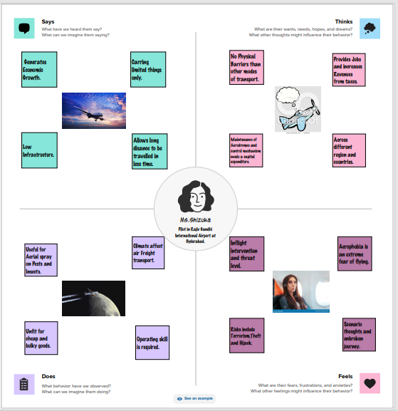

**2.2 IDEATION AND BRAINSTORMING MAP**

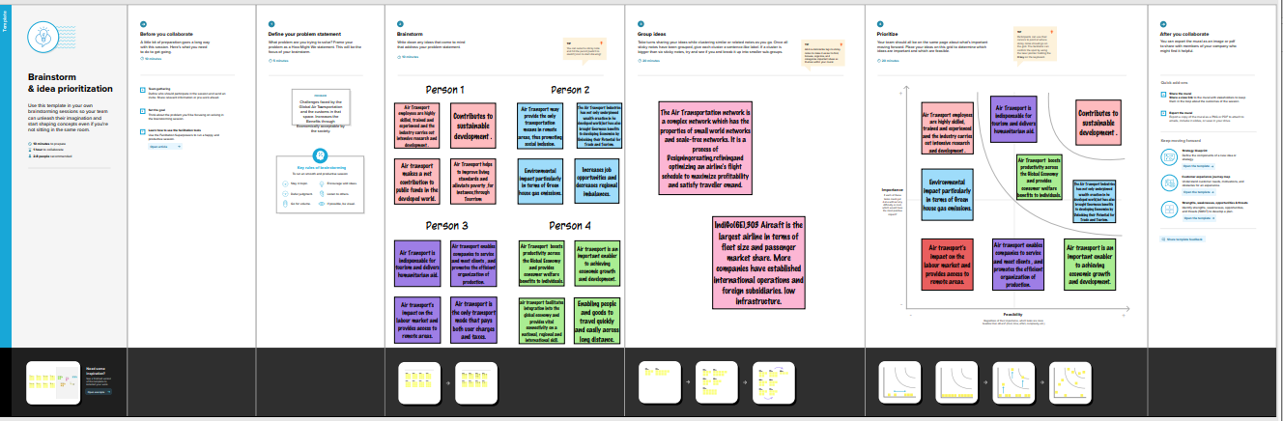

**3. RESULT**

**3.1 DASHBOARD**

***WORLD MAP OF AIRPORTS AIRLINES WITHIN A COUNTRY***

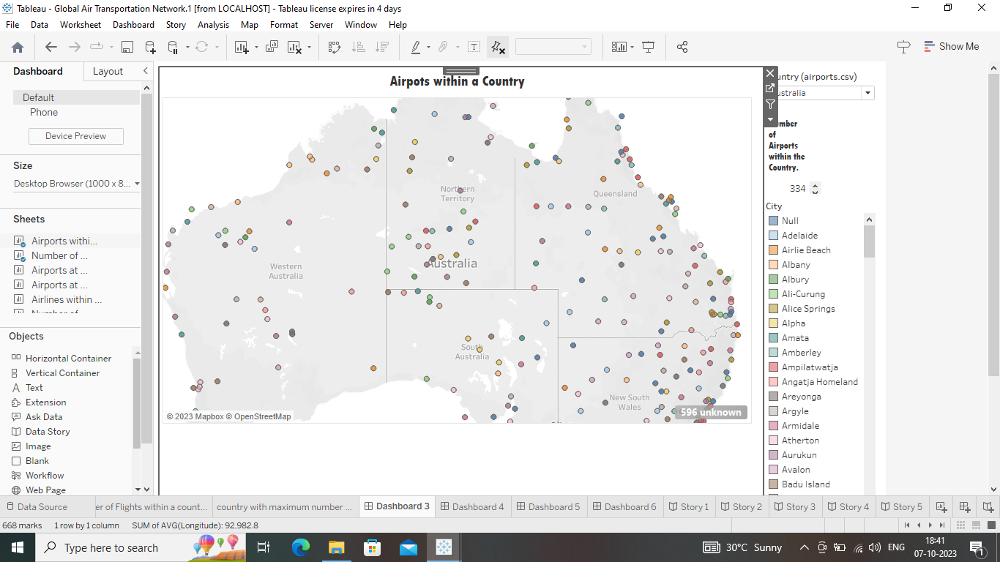 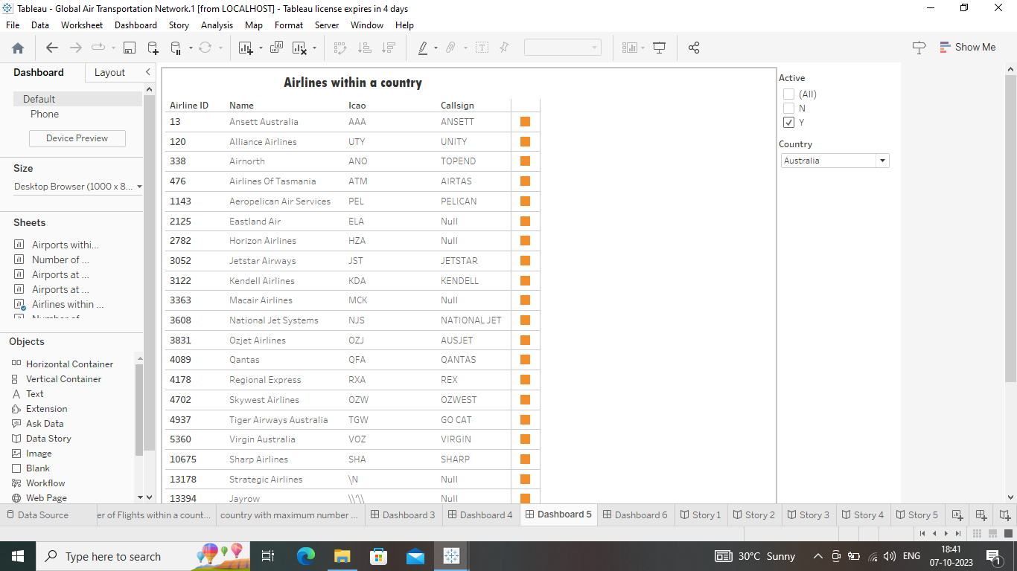

**BAR GRAPH FOR AIRPORTS AIRPORTS AT HIGHER ALTITUDE**

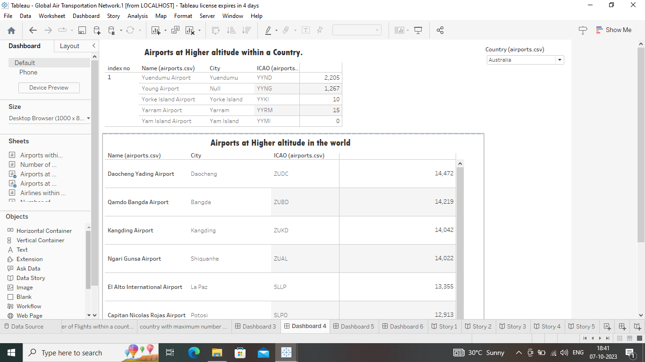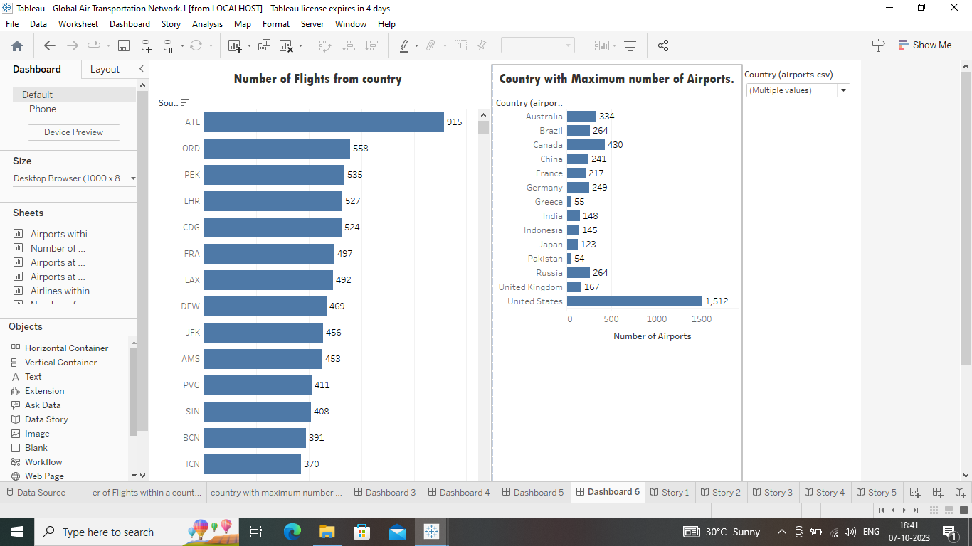

**3.2 STORY**

**WORLD MAP**

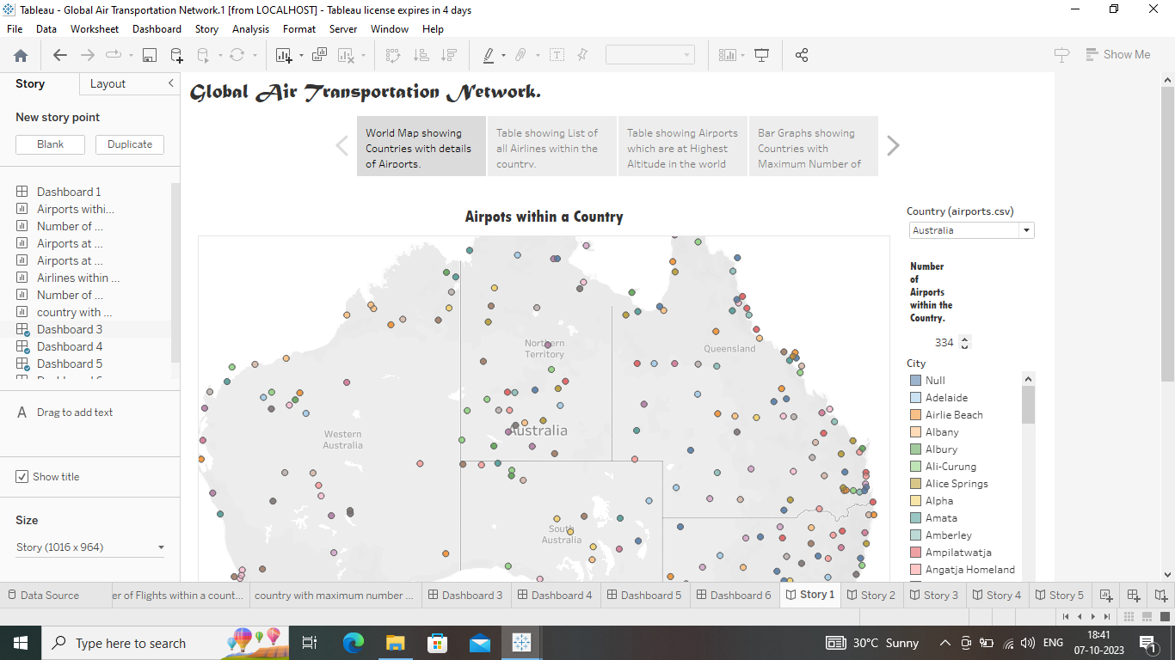

**BAR GRAPH**

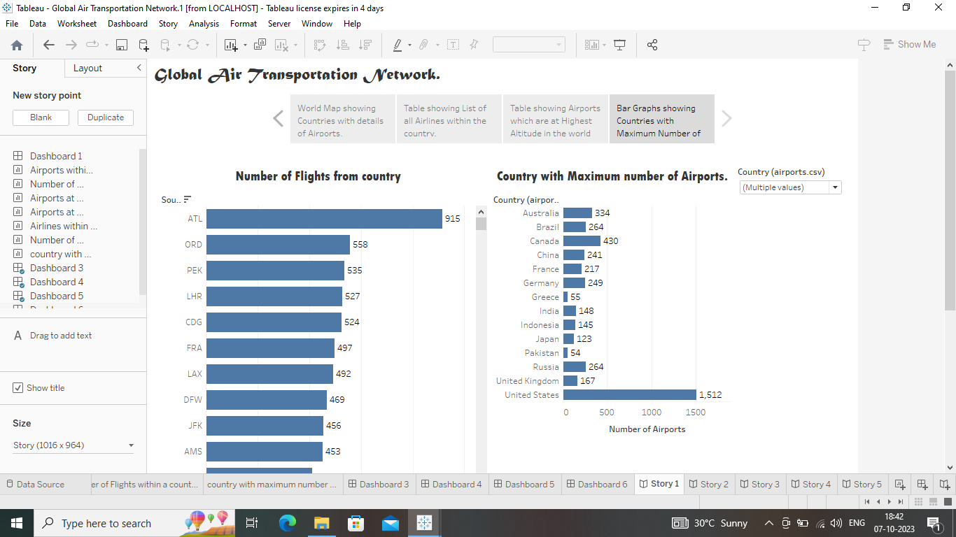

4. ADVANTAGES AND DISADVANTAGES

4.1 ADVANTAGES

* ***High Speed***
* ***Air is the type of freight capable of travelling long distances in short periods of time.***
* ***It enables fast travel, making it possible to reach destinations around the world within hours.***
* ***Natural Route***
* ***An aircraft can fly to any location without seeing any natural obstacles or barriers. Since customs formalities are easily compiled.***
* ***It eliminates the need for more time to seek clearance.***
* ***Air travel is useful for relief operations during Earthquakes, Floods, Accidents and Famines.***
* ***High standard of security***
* ***High standard of protection with a low risk of robbery and injury.***
* ***Shipping by air has a high degree of security since airport safety restrictions on cargo are strictly enforced.***
* ***Tightly controlled airport controls also minimize cargo theft and loss.***
* ***Emergency Response***
* ***Modern aircraft are becoming more fuel-efficient and environmentally friendly, which can reduce the carbon footprint of long-distance travel.***
* ***Globalization***
* ***Air transportation fosters globalization by enabling quick transfers between different modes of transportation.***
* ***Economic Impact***
* ***It contributes significantly to the global economy by creating jobs, supporting tourism, facilitating international trade and business.***

**4.2 DISADVANTAGES**

* ***Risky***
* ***Air travel is the riskiest mode of transport, since there can be considerable losses to goods, customer and crews as a result of a minor crash.***
* *Cost*
* *Air travel is considered to be the most expensive means of transportation.*
* *The cost of maintaining aircraft is higher and the costs for the building of Aerodromes and avions are much higher.*
* *Capacity for small carriage*
* *The aircraft have no room ad not ideal for carriage of voluminous and cheaper materials.*
* *Enormous Investment*
* *Air travel calls for enormous spending in aerodrome building and servicing.*
* *It also calls for professional, qualified staff that need a significant investment.*
* *Weather Disruptions*
* *Air Travel is highly dependent on weather conditions and adverse weather can lead to flight cancellations and delays.*
* *Health concerns*
* *Extended air travel can lead to healh issues like jet lag and deep vein thrombosis (DVT).*
* *Risk of Accidents*
* *While air travel is generally safe, the consequences of accidents can be Catastrophic.*

**5. APPLICATIONS**

* ***Passenger travel : The global air transportation network enables millions of people to travel for Business, leisure and personal reasons.***
* ***Cargo transportation : Air cargo plays a crucial role in transporting goods quickly and efficiently, supporting global trade.***
* ***Emergency Response : Air transport is vital for delivering humanitarian aid, medical supplies and emergency personal during crises.***
* ***Military operations : Air transportation is essential for military operations, including troop deployment, reconnaissance and logistics.***
* ***Real-time flight information : Display real-time flight status, including departure and arrival times, delays and gate information.***
* ***Flight Booking : Allow users to search, book and manage flights from various airlines worldwide.***
* ***Airport information : Provide details about airports such as terminal maps, services and amenities.***
* ***Visa and entry Requirements ; Provide information about visa requirements and entry regulations for different countries.***
* ***Global coverage : Ensure that the app covers a wide range of airlines and destinations globally.***
* ***Language and Currency conversion : Assist travelers with language translations and currency conversions.***
* ***Loyalty Programs : Integrate with frequency flyer programs for accumulating and redeeming points.***
* ***Travel Itinerary : Generate and manage complete travel itineraries.***
* ***Baggage Tracking : Help users track their checked baggage.***
* ***Travel Insurance : Offer options for purchasing travel insurance.***
* ***Local Services and Transportation : Include information on local transportation options and services at their destinations.***
* ***User Reviews and Ratings : Allow travellers to share their experiences and read reviews of airlines and airports.***
* ***Customer support : Offer 24/7 customer support for assistance with bookings or issues during travel.***
* ***Accessibility : Ensure the app is accessible to people with disabilities.***

**6. FUTURE SCOPE**

* *Technological Advancements : Continued advancements in aircraft design and propulsion technology are expected. This includes the development of more fuel-efficient and environmentally friendly aircraft, as well as the potential for supersonic and even hypersonic flight.*
* *Sustainable Aviation : Environmental concerns will drive the aviation industry to focus on sustainability. Electric and hybrid-electric propulsion systems, as well as the increased use of Bio-fuels, are expected to play a role in reducing the carbon footprint of air travel.*
* *Autonomous Aircraft : The development and integration of autonomous or semi-autonomous aircraft are on the horizon. This could impact the efficiency and safety of air transportation.*
* *Urban Air Mobility (UAM) : UAM, involving electric vertical takeoff and landing (EVTOL) aircraft, is a growing area. It has the potential to transform urban transportation and reduce congestion in crowded cities.*
* *Digitalization And Data Analytics : The aviation industry will become more data-driven, using analytics to optimize operations, improve safety, and enhance the passenger experience.*
* *Infrastructure Development : Expanding and modernizing airports and air traffic management systems will be essential to accommodate the growing demand for air travel.*
* *Global Connectivity : Air travel routes will continue to expand, connecting more cities and regions. Emerging markets may become key players in the global aviation industry.*
* *Security and Safety : Ensuring the safety and security of air transportation will remain a top priority, with continued innovations in security measures and technology.*
* *Passenger Experience : Airlines and airports will focus on improving the passenger experience, including in-flight entertainment, comfort, and the seamless integration of technology into the travel process.*
* *Regulatory Changes : Aviation regulations will need to adapt to the evolving landscape, addressing safety, environmental and technological considerations.*

7. CONCLUSION

*The global air transportation network plays a pivotal role in connecting people, goods and cultures around the world. It has significantly contributed to economic development, international trade and cultural exchange. However, it also faces challenges related to sustainability, security and congestion that need to be addressed to ensure its continued growth and positive impact on our interconnected world. As technology and infrastructure continue to evolve, the future of the global air transportation network holds both opportunities and responsibilities to create a more efficient, sustainable and accessible system for all. Now a major contributor to globalization and is continually reshaping itself to meet the demands of the economic and social integration that globalization engenders, Economically, in static terms, globalization occurs to facilitate the greater division of labor and allows countries to exploit their comparative advantage more completely. Perhaps, however, more importantly, in the longer term, globalization stimulates technology and labor transfers and allows the dynamism that accompanies entrepreneurial activities to stimulate the development of new technologies and processes that enhance global welfare. To allow the flows of ideas, goods and persons that facilities both static and dynamic efficiency on a global scale, air transport has played a role in the past, and it seems inevitable that it this role will continue in the future.*